Azure Monitoring Hackathon HammerDB QuickStart
From the Visual Studio Server, download the latest version of HammerDB
Download and Install HammerDB tool on the Visual Studio VM
www.hammerdb.com
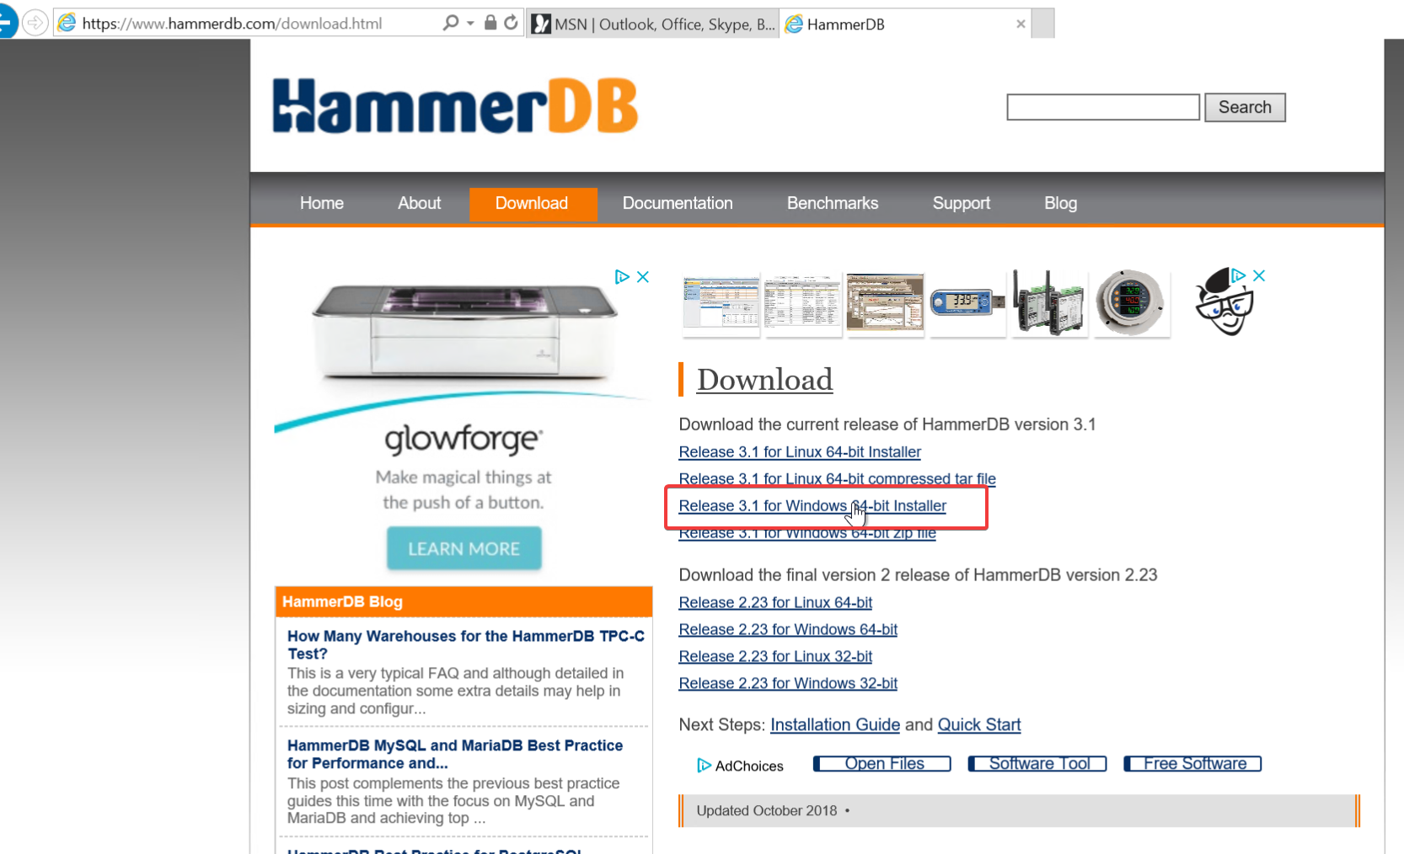
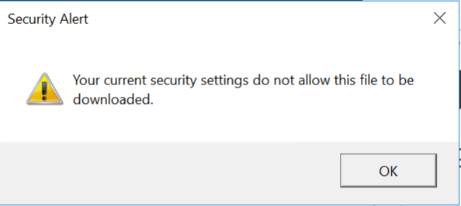
If you get this Security Warning, go to Internet Options.
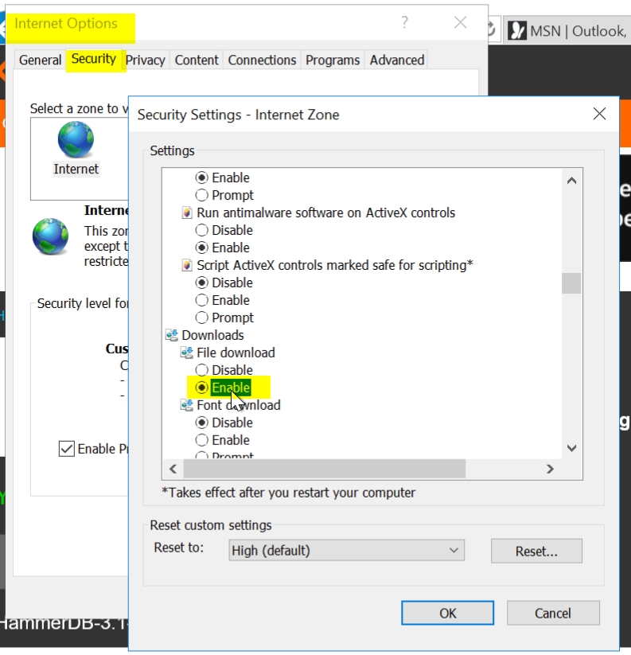
Security \ Security Settings \ Downloads \ File download \ Enable
Click OK
Try again
Click Actions and accept the warnings
Tip: If you end up closing HammerDB you have to go to C:\Program Files\HammerDB-3.1 and run the batch file
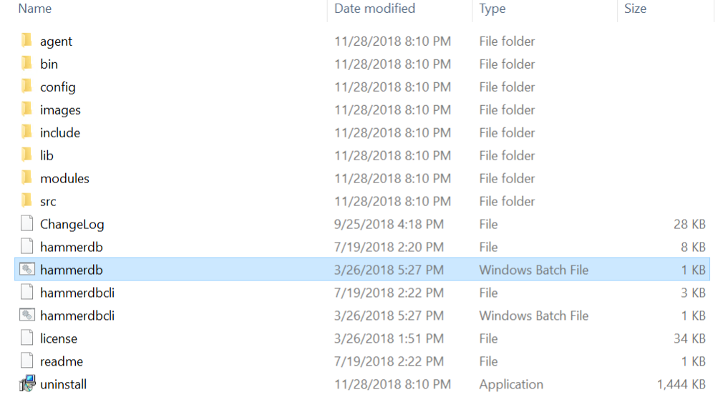
- Use HammerDB to create transaction load
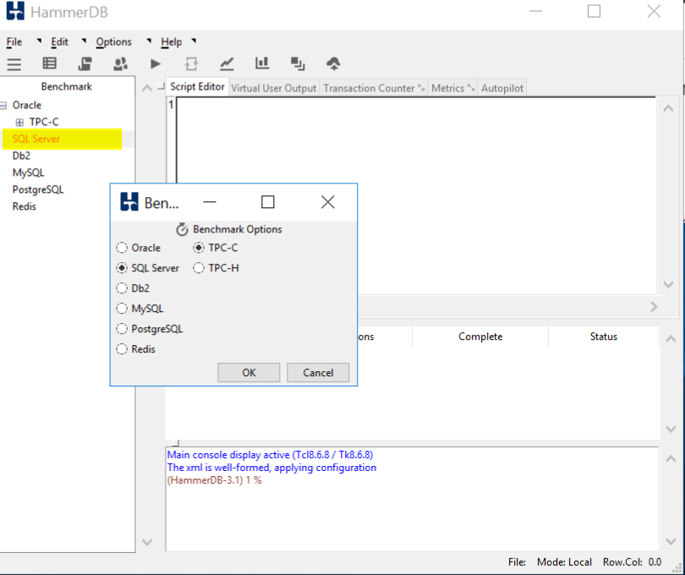
Double click on SQL Server and click OK, and OK on the confirm popup
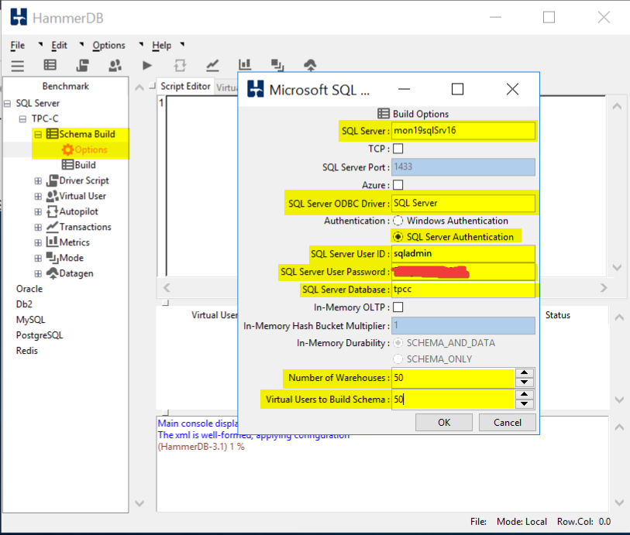
Drill into SQL Server \ TPC-C \ Schema Build and double click on Options
Modify the Build Options for the following:
SQL Server: Name of your SQL Server
SQL Server ODBC Driver: SQL Server
Authentication: SQL Server Authentication
SQL Server User ID: sqladmin
SQL Server User Password: <password you stored in the Key Vault>
SQL Server Database: tpcc
Number of Warehouses: 50
Virtual Users to Build Schema: 50
Note: Setting the last two at 50 should generate enough load to trip a threshold and run long enough for you to graph
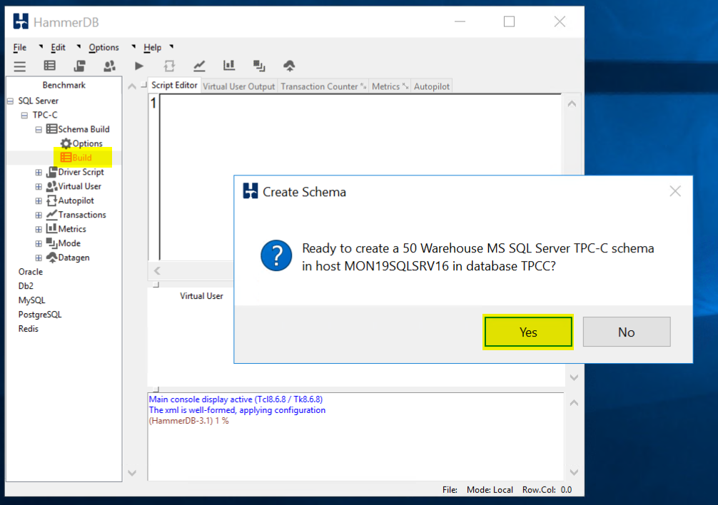
Double click on Build and Click Yes to kick of a load test.
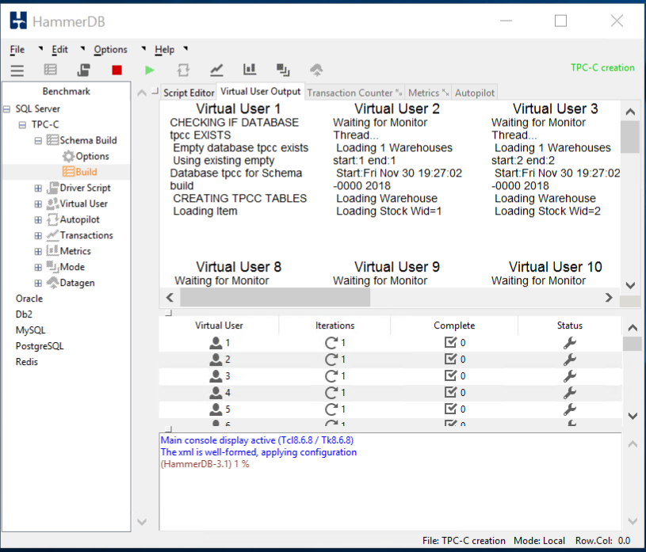
When the test is running it should like this.
TIP: If you would like to run a second test you must first delete the database you created and recreate it. HammerDB will not run a test against a database that has data in it. When you run a test is fills the database with a bunch of sample data.

